Khalil Somani

6/5/2016

Communicating Research Finals Draft

**Introduction**

Study spaces are areas that facilitate productivity for students doing various types of work. My research was conducted in order to understand study spaces at the University of Washington. My goals were to observe how students use campus study spaces, to learn details about why they study or don’t study in campus study spaces, and to understand and assess those findings. I hoped to learn what makes users more comfortable in a space and how to maximize user productivity regardless of individual differences. By going through this rigorous process, I wanted to answer the question, “How can I make campus study spaces ideal for students?”

It is of crucial importance that students utilize spaces that meet their needs, especially because study spaces have been found to detract from learning in some cases (Nonis & Hudson, 2010). Therefore, it is crucial to design spaces that provide interactions, resources, and atmospheres that not only cater to academics, but also all the requirements of the user (Applegate, 2009).

My findings were derived from 3 deep-hanging out field observations in Odegaard Library, Alder Commons, and Savery Hall for 1.5 hours each, as well as semi-structured interviews with 3 users and a survey of 34 users. The findings will be used to create on-campus study spaces that accommodate key user needs.

My target users were UW students that utilize study spaces on campus on a regular basis. It is those students who will use the future study spaces that I will design, and this will hopefully help them achieve all their goals in the space. I am designing for juniors specifically because my surveys showed that the majority (56%) of my participants were juniors, which seems to mean that many of the people interested in creating improved study spaces on campus are juniors.

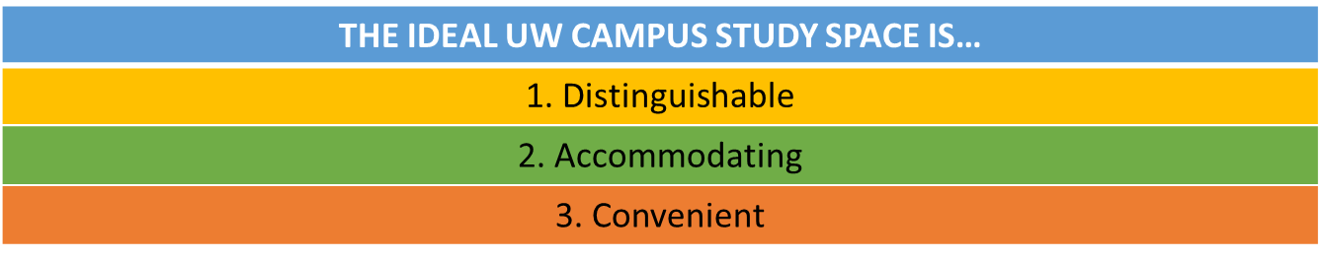

*Framework of Results: Users want spaces that are distinguishable, accommodating, and convenient*

**Key Findings**

Easily Distinguishable Quiet/Isolated and Social/Interactive Spaces

Users differ greatly on when they prefer to do work in quiet/isolated spaces vs. social/interactive spaces, but prefer to have both available. They use spaces more if they are easily distinguishable.

**Proof**

I came into this research project with the assumption that users would prefer to study in quiet spaces. This was confirmed in my field research, where after observing 59 total users in Odegaard, Alder Commons, and Savery, I found most users preferred spaces that were quiet/isolating from others (44%). However, my interviews suggested noise/interaction were beneficial to users while doing light work, but quiet/isolation was preferred for difficult work. This conclusion came from statements like P2 saying, “I like it when it’s fairly quiet… sitting in a Poplar study space by myself that would be ideal,” which sharply contrasts to P3 stating, “[In the library] if I see someone working really hard it’s like I should be working that hard.”

In my surveys, a majority of users considered libraries to be noisy (65%), but still considered them the most popular space to study (53%). Dorms were found be both noisy and quiet, but half of the participants stated that they did not use dorm spaces to study at all (50%), likely the result of participants wanting either a quiet or an interactive space but not both.

**Discussion**

It aggravates users to have to study in atmospheres that are not enhancing the work they are doing. As seen in my framework, it is important to have a clear distinction between quiet/isolated study areas and social/interactive study areas. Providing spaces that accommodate all users and types of work means users are forced to study in a space that fits the “average” student, but doesn’t fit their study needs as an individual. Users either liked spaces that were very noisy or very quiet. They liked libraries the most, likely because having the availability of “sub-atmospheres” with distinct areas seemed to attract students.

**Design Recommendations**

Study spaces should be designed to have distinct separation between quiet/isolated areas and noisy/interactive areas so users can choose according to their personal or academic needs. Figure 1 below illustrates how the noisy/interactive area would be much more open and shared with others while the quiet/isolated area would involve many more individual rooms with ample space. These areas should be clearly distinguished and separated but easy to access. There should be one large floor divided by a wall, with distinct signs on one side saying, “Interactive Study: A Space for Collaboration and Discussion” and another sign on the other side saying “Quiet Study: A Space for Isolated Focus and Concentration”. There should be a door between the two so that users can easily access each one depending on their work.

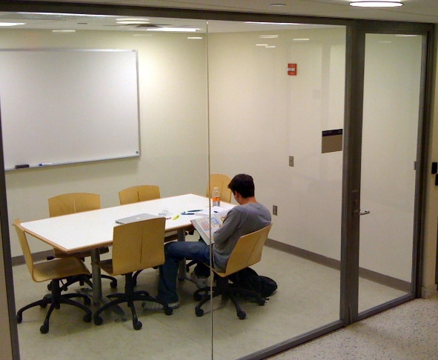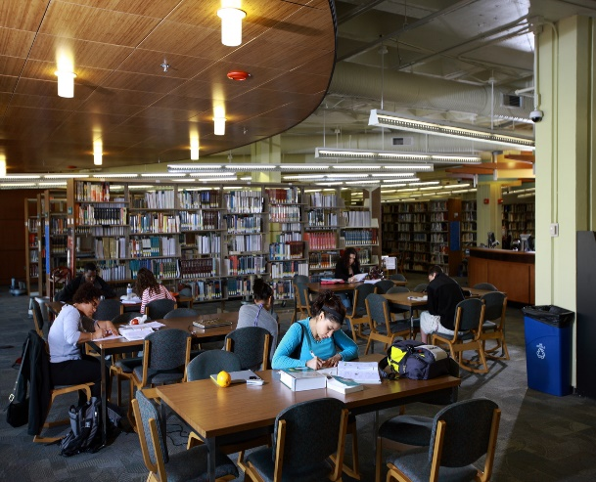

*Figure 1: Design of Interactive Study Area (Left) Vs. Design of Isolated Room in Quiet Study area (right)*

*Accommodating of all Types of Study Materials (Especially Laptops)*

Users prefer spaces that allow them to use all types of study materials, especially laptops, which are universally utilized in every kind of space. More materials are preferred for versatility when studying.

**Proof**

In all of my research sessions, I found laptops to be the most popular study material, and spaces that could best accommodate laptops were preferred by users. In my field research, of 59 total users from the three spaces I observed, the majority of study spaces users were using laptops (49%). After completing my interviews, 100% of my participants felt laptops were the best material for productive studying, especially for readings and lectures. This was illustrated best by P3 who said, “It’s easier to get to multiple resources [on a laptop].”

In my surveys, I confirmed laptops were universally used in campus spaces, seen in the majority of users calling laptops their preferred study material (62%). Notebooks, physical books, and textbooks were also used in all of the main study spaces, and library spaces specifically were found to include group studying and library desktops.

**Discussion**

Laptops specifically led to greater productivity among users and allowed users to easily access resources, making them a key factor in an ideal study space. Though not all users need laptops, they are used consistently in every type of space, so spaces should accommodate laptop users. Those who will be using those spaces need comfort, outlets, and varying places to sit like couches, chairs, desks and tables. Users also seem to like spaces like libraries that allow for notebook, textbook, group studying, and desktop use, which means ideal spaces are not solely designed for laptop use. As seen in my framework, it is important to have a laptop-friendly space that also allows for these other materials.

**Design Recommendations**

New study spaces should be designed to be extremely laptop-friendly. To do this, there should be outlets by every work station for laptop charging, and many different work areas to accommodate for laptop versatility by having individual desks, small tables, large tables, couches, and chairs in every space. This is well illustrated in Figure 2 below which shows tables, couches, and lounge chairs integrated into a study space, allowing for the user to choose what will make them most comfortable. Many times, laptop use also involves listening to lectures or music for productive work, so study spaces should provide headphones for users to borrow upon entrance to the space. The many study methods and materials offered in libraries lend to their popularity, so study spaces should have tables dedicated to notebook work and reading, as well as group work. Also there should be table lights at each study spot for reading, and a section with desktop computers.

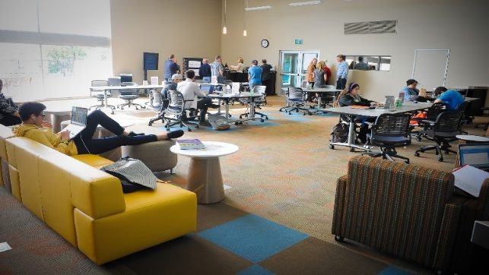

*Figure 2: Design of a Laptop-Friendly Space with Varied Forms of Seating for Student Work*

*Conveniently Located and Available*

Users preferred study spaces that were located close to their classes, food/drink, housing, and that were readily open/available for studying. These factors allowed students to be more efficient.

**Proof**

My interviews showed that having food/drink close by was mentioned by 100% of users because it leads to efficient study time, seen by P1 stating, “If my study space is close to food I can grab a snack quickly and I can get more work done.” Users also choose study spaces close to classes, which is why two of my three participants felt libraries were most convenient. Availability was another factor, as seen by P1 saying, “[The ideal space] would also have a lot of table space and availability so I’m not worried about finding a place to study.”

In my survey, I saw that juniors were the largest demographic of my participants (56%), and that participants as a whole only used study spaces 1-2 days per week (41%). I hypothesized that this was the result of upperclassmen living far from on-campus spaces. I also saw that libraries were considered convenient spaces (70%), likely for food/drink and proximity to classes, but no users labeled classrooms and dorms as convenient.

**Discussion**

As seen in my framework, it is important to have proximity to resources, as well as have study spots be available for when students arrive. It takes time to get to study spaces after class, or from home if users are far away. This applies to food/drink if the nearest location is not close to the space. This is an important finding because convenience allows users to not waste time going places, and instead use that time for productive studying. Concerning availability, spaces with ample room are enjoyed by users because they don’t have to waste time looking for a spot.

**Design Recommendations**

All these factors imply a need for study spaces that allow for efficiency, so future spaces should have a cafe area within the space where users can get food/drink. This is illustrated in Figure 3 below, which shows a cafe integrated into a study space. This should be located within 50 ft. of the main study area in every space. Classes should also be within close proximity to study spaces to minimize walking time, and spaces should specifically be located within 100 feet of the quad and fountain to be close to upperclassmen classes. Spaces should have at least 20 large tables and 50 desks to accommodate as many students as possible, and stay open 24 hours a day. Tables and desks should take up at least ¾ of available space in the study area to maximize accommodation.

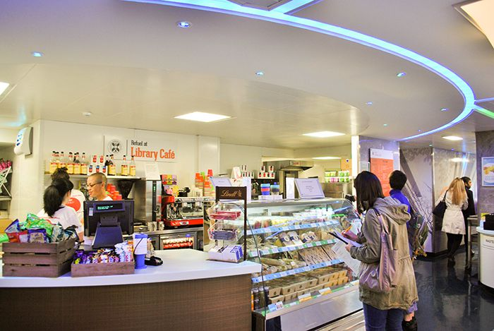

*Figure 3: Design of a cafe integrated into a study space that is easily accessible to students doing work*

**Future Research Considerations**

Concerning future field work, I hope to observe how not just UW students but also how working professionals, employees, and campus visitors use study spaces on campus. I made my field observations at night, which was typically fine for students but not for users like working professionals who do not usually have access to campus spaces or study late at night. I have the opportunity in the future to make field study observations during the day, which will allow me to make the space productive and comfortable for other users in addition to students.

Concerning future interviews, I hope to learn how users from different demographics like race, gender, etc. choose to study in certain spaces on campus. In my interviews, I was selecting for convenience, and ended up having only female participants, which may have given me different data than I would have gotten with mixed participants. I have the opportunity in the future to interview users from varying backgrounds, which will give me an even better understanding of who on-campus study space users are, and help me design an even more ideal space.

Concerning future surveys, I hope to learn specifically how many members in each of various demographics (age, race, gender, etc.) use certain study spaces, which would allow me to see patterns among users. In my surveys, I did not have clear comparisons like this, which led to complex and vague comparisons. For example, I ran into a problem with a social disposition/interaction metric where I made comparisons about doing difficult vs. easy work and social interaction preference in a study space. This was both difficult to understand and lead to data misinterpretation. In the future, I have the opportunity to put data clarity before ambition by creating questions which I can compare clearly and effectively.

**References**

Applegate, R. (2009). The library is for studying: Student preferences for study space. *The Journal of Academic Librarianship*, *35*(4), 341-346.

Nonis, S. A., & Hudson, G. I. (2010). Performance of college students: Impact of study time and study habits. *Journal of Education for Business*, *85*(4), 229-238.